|  |  |
| --- | --- |
| **DevOps Consultant – Noida** | |
| **Candidate Name** | Monica Kumari |
| **Current Company** | Nagarro Software Pvt. Ltd. |
| **Current Designation** | Devops Engineer |
| **Current Location/Native** | Noida |
| **Education** | BSc |
| **Experience** | 4.6 Years |

|  |  |
| --- | --- |
| Skills | **Years of Experience** |
| DevOps | 4.6 years |
| Jenkins | 4.6 years |
| CI/CD | 4.6 years |
| Ansible | 4.6 years |
| Kubernets | 4 month |
| Monitoring tools like Grafana, Prometheus, ELK Stack | 3.6 years |
| OS & Orchestration | 4.6 years |
| scripting like Shell/Python/Groovy/YAML & DSL scripts | shell, YAML - 2 years |

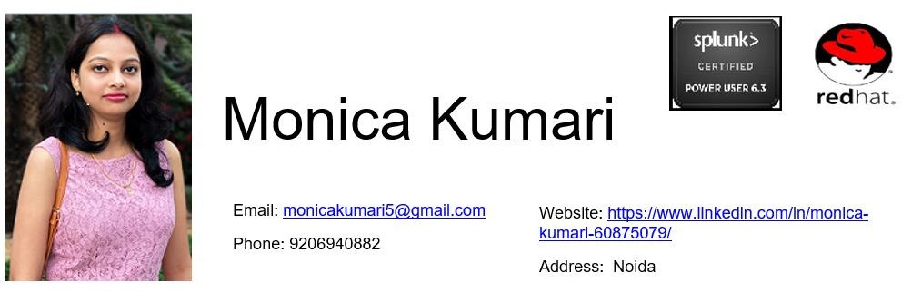

# Professional Summary

* DevOps Professional with more than **4 years 6 month** of experience in IT industry comprising of build Release management, software configuration, design, develop, build automation and cloud implementation.
* Proficient in writing Cloud Formation Templates (CFT) / Terraform in YAML/TF and JSON formats to build the AWS services with the paradigm of Infrastructure as a Code (IAC).
* Proficient in AWS services like VPC, EC2, ECS, EBS, RDS, S3, EBS, IAM, ELB, Auto Scaling, Route 53, Cloud Front, Cloud Watch, Cloud Trail, SQS, SNS, EMR, Lambda, System Manager, Step Function, Guard Duty, AWS Config, KMS etc.
* Strong experience on DevOps essential tools like Ansible, Docker, Kubernetes, Subversion (SVN), GIT, Jenkins, Maven, Artifactory, SonarQube, Elasticsearch, Logstash, AWS.
* Acquired practical exposure with Continuous Integration/Continuous Delivery (CI/CD) tools like Jenkins to merge development with testing through pipelines.
* Exposed to build tools like ANT, MAVEN and bug tracking tool JIRA in the work environment.
* Experience in creating Docker Containers leveraging existing Linux Containers ans AMI’s in addition to creating Docker Containers from scratch.
* Experienced in version control and source code management tool like GIT, Gitlab.
* Experienced in tools administration like JIRA, Confluence, Artifactory and Sonar.
* Worked on various operating systems like RHEL and Windows.
* Possess high working qualities with good interpersonal skills, high motivation, fast learner, good team player and very proactive in problem solving to provide best solutions.
* Strong experience on DevOps monitoring tools like Nagios, ELK, Prometheus, Grafana, Kibana, Zabbix, Solarwind, SPC, Pingdom, Splunk.

# Work Experience

## Nagarro May 2018 — Present

DevOps Senior Engineer, Technology

#### Project Name: Center Of Excellence (COE), Linux Admin/Devops/ Cloud Engineering Team (present)

In this project my role was to develop, support, Linux admin and innovate the DevOps toolsets and applications, used across Nagarro and automate redundant tasks with scripting knowledge and to imbibe DevOps best practices across organization and provide support across the Nagarro organization.

* Ensured optimization/improvement of tools set by regular troubleshooting and monitoring.
* Proactively implemented automation scripts for maintenance and monitoring – Add user’s to JIRA groups and on Nagarro servers, Server logs cleanup, Directory cleanup, script for automated mails to Leads & admins and plan set-up and run plan these scripts using Jenkins. Worked on Jira and confluence setup and upgrade.
* Tools support in Nagarro as well as on call support, in case of any incidents.
* **Creating CI/CD pipelines**. Developed Scripts in **Shell** and **Ansible** to assist in daily tasks as well as automation of manual processes. I have been created Ansible scripts mainly for software installation like WebLogic, Tomcat, MySQL, Oracle, Jboss, Mongo dB etc.
* POC of new tools to be on boarded like Docker, DevOpsLab & NSC (Bothe are Nagarro Internal Tools) and documentations. Analysis of different clients – GIT Bash, Tortoise GIT and creating documents on their installation methos and usage along with training people on them; as the yool is newly on-boarded.
* Tools training, walkthrough and presentations to users. Troubleshooting and fixing any build related issues.
* Scheduled, documented and implemented production releases through change management.
* Installation, Analysis, Upgrade, Integration and administration of tools & Perform Maintenance activities for applications/tools.
* Possess good knowledge in Creating and launching EC2 instances using AMI,S of Linux, Ubuntu, RHEL and Windows.
* Created S3 buckets in AWS environment to store files, sometimes which are required to serve static content for web application.
* Created and configured elastic load balancers and auto scaling groups to distribute the traffic and to have a cost efficient, fault tolerant and highly available environment.
* Worked on a DevOps Jenkins Pipeline. In that application code, Checkout from SVN/Git < Build code with Maven < I did SonarQube analysis < Deployed the artifact onto Artifactory < Build Docker Image < Push to Nagarro DTR < Deployed the CMP application on Kubernetes Cluster using Helm Chart with 3 replicas < Created a Terraform script to deploy an EC2 instance and deployed the same application over there < Created setup monitoring of the application using Prometheus and Grafana

< Mail Triggered for job failure/success.

* MySQL performance tuning creating users and managing permissions.
* Experienced professional with trouble shooting capabilities on Linux platform. Knowledge about Linux admin task like disk partitioning, Lamp setup, Monitoring servers/services (CPU, Memory, Swap Memory, Hard disk, MySQL service, Http service and response time etc)
* Worked on load balancing task with nginx & apache web server on application servers. Also knowledge about HAproxy, LVS.
* Worked with a team on creating new solution graphical dashboard to filter info relevant to cost optimization and CPU memory usage as well as alerting of containers, services, pods running on Kubernetes cluster, using Kube-state-metrics, Heapster, Prometheus, Cadvisor, Kibana, Grafana dashboard.

**Technologies used** : Kubernetes, Basic Python, Unix, MySQL, Ansible

## SAP LAB Mar 2016 — May 2018

Associate Consultant – Linux Admin

#### Project Name: SAP Success Factor HCM (Human Capital Management) Cloud Support, BIZX & LMS (learning management system) Engineering Team (present)

In this project my role as L1 member is to work closely with BIZX/LMS team. In this project my role was to develop, and admin support all delivery tools used within the organization.

* Ensured optimization/improvement of tools set by regular troubleshooting and monitoring.
* Installation and configuration of Zabbix Server, Zabbix Proxy and Zabbix Agent .Knowledge on Zabbix API’S, Macros g file, SNMP integration, JMX, DB monitoring, Low level discovery etc. Knowledge to Create adaptions, Create templates.
* Installation and Configuration of Jboss AS5 and EAP6.2 etc. Application servers. Experience in Apache integration with Jboss (mod_cluster) & (mod_jk). Setup of Highly available clustered Jboss Application server environment using multiple Standalone instances. Deployment of jar, war, ear and rar files to Jboss instances using web console. Creation of Server Groups and profile assignments to the server groups in a domain. Configuration of JDBS Data sources and connection pools.
* Troubleshooting issues related to application slowness, struck threads and Out of Memory issues. Resolving P2 and P3 tickets. Tuning of JVM parameters to achieve better performance. Production monitoring and support for multiple JBOSS instances across non-production, QA, UAT, Training other critical environments.
* Good experience in installing and setting up Tomcat 7x. Having grip on server Start-up & Shutdown. Having good experience in Deploying application to tomcat server. Deployment of war and ear files to tomcat servers through console.

# Technical Skills

* **AWS Services**: EC2, S3, ELB, Auto Scaling Groups, CF, VPC, ROUTE, Subnet, Cloud Watch, IAM, Dynamo DB, SNS, EMR, Lambda, AWS, CLI.
* **CI/CD Tools**: Jenkins
* **Build Tools**: ANT, MAVEN
* **Web Technologies**: HTML5
* **Scripting**: BASH/SHELL, Python
* **Programming**: Basic C, MATLAB, SQL/PLSQL
* **Database Software**: Oracle, MySQL
* **Version Tools**: GIT, SVN

# Certifications

### Splunk-Power User Certification Version : 6.3 Certification no: 137256

* Red Hat Certified System Administrator (RHCSA) on RHEL 6. Certification no: 130-156-581
* Red Hat Certified Engineers (RHCE) on RHEL 6. Certification no: 130-156-581
* Certification in MTA Certification number: E731-2249 and MCP Certification number: E731- 2250 and MOS.

Education

* Bachelor of Computer Science, Arya College Of Engineering & I.T, Jaipur,India.

Languages

* English: Professional Working Proficiency